A Title Contains Words Needed to Adequately Describe the Content of Your Research

Author Name^{1*}, Author Name¹, Author Name²

¹ Faculty Name, University Name, City, Country
² Faculty Name, University Name, City, Country

*Corresponding Author: author@university.edu
________________________________________________________________________________________

Abstract: An abstract summarizes, usually in one paragraph of 300 words or less, the major aspects of the entire paper in a prescribed sequence that includes the overall purpose of the study and the research problem, the basic design of the study, major findings as a result of your analysis; and a brief summary of your interpretations and conclusions.

Keywords: keyword, keyword, keyword (not more than 5 keywords)
_________________________________________________________________________

1. Introduction – Heading 1 (TNR, 12, Bold, Align Left, Capitalize Each Word)
In the development of the community and society, the quality of life of the elderly becomes significant. In 2018, Malaysia's population is predicted to be 32.4 million, up from 32 million in 2017 with a 1.1 percent annual growth rate. …..
(TNR, 12, single spacing, justify)

2. Literature Review – Heading 1 (TNR, 12, Bold, Align Left, Capitalize Each Word)
Definition of Quality of Life – Heading 2 (TNR, 12, Bold, Italic, Capitalize Each Word)
In most aspects, medical research has dominated the body of literature on quality of life. However, quality of life is widely recognized beyond medical discourse to other fields including sociology, psychology, environmental studies, social work, and social policy (Smith, 2000).
(TNR, 12, single spacing, justify)

Tables and Figures
Tables usually show numerical value or textual information and are almost always characterized by a row-column structure. Any type of illustration other than a table is referred to as a figure. The title should be placed at the top of a table. For the figure, the title should be placed at the bottom of the figure.

Table 1: Title at the top of a Table (TNR, 10, single spacing, bold, center)
Example | Example | Example
Example | Example | Example
Example | Example | Example

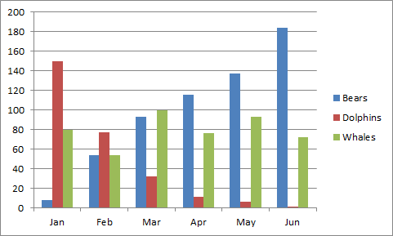
Figure 1: Title at the bottom of a Figure (TNR, 10, single spacing, bold, center)
Source: (TNR,10, Single Spacing, center, Capitalize Each Word)

3. Discussion and Conclusion
The discussion and conclusions section should answer your research questions and explain what your results mean. In other words, the majority of the discussion and conclusions section should be an interpretation of your results.
(TNR, 12, single spacing, justify)

References (APA 6th Edition Format)

PLEASE SUBMIT YOUR FULL PAPER IN MICROSOFT WORD FORMAT

